

# **Non-Medical Prescriber Data Request Form**

Prescribing Informatics Team, Medicines Optimisation, NHS Nottingham & Nottinghamshire ICB

**Select requester option below**

Choose an item.

**Full name of requester**

Click or tap here to enter text.

**Job title**

Click or tap here to enter text.

**Email address**

Click or tap here to enter text.

**Practice/Organisation**

*Enter the department and organisation the request is being made on behalf of*

Click or tap here to enter text.

**Please state the reason for requesting NMP data**

Click or tap here to enter text.

**Full Name of Non-Medical Prescriber**

*Please include any previous names that may be registered if recently changed*

Click or tap here to enter text.

**Prescriber code/s (if known)**

Click or tap here to enter text.

**Are you requesting data for a NMP working at multiple sites?**

Choose an item.

**Please state Practice sites\***

*Include practice code if known*

Click or tap here to enter text.

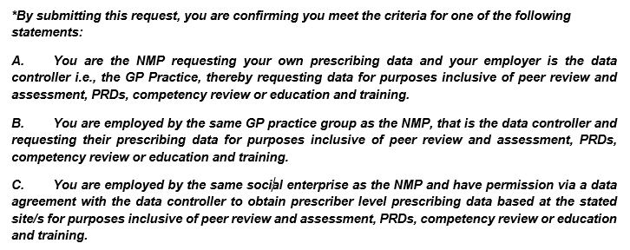

*Data supplied will be the latest 6 months available on the ePACT2 NHSBSA system. Please note the latest available month is approximately 6-8 weeks prior to the date of request.*

***If you require a specific timeframe, please state below:***

Click or tap here to enter text.

**Requester signature**

*(open dialog box by double clicking the signature line below)*



Date: Click or tap to enter a date.

Please submit your completed form to [***nnicb-nn.prescribinganalysts@nhs.net***](mailto:nnicb-nn.prescribinganalysts@nhs.net)