**Direct acting oral anticoagulants (DOACs) use in non-valvular atrial fibrillation (NVAF)**

**Dosing and monitoring audit information sheet**

This information is aimed for use by healthcare professionals in a GP practice.

**Key Message:**

* Toolkit of searches to identify patients requiring monitoring and review for under or over dosing of DOAC in line with the [Nottinghamshire Area Prescribing Committee (Notts APC)  Atrial Fibrillation (Non-valvular): prescriber decision support](https://gbr01.safelinks.protection.outlook.com/?url=https%3A%2F%2Fwww.nottsapc.nhs.uk%2Fmedia%2Fvlsfl14j%2Fanticoagulants-in-af.pdf%3FUNLID%3D45973983820242295710&data=05%7C02%7Cumema.adamjee%40nhs.net%7C98634d8b17a94ceea47b08dc638da142%7C37c354b285b047f5b22207b48d774ee3%7C0%7C0%7C638494707140367585%7CUnknown%7CTWFpbGZsb3d8eyJWIjoiMC4wLjAwMDAiLCJQIjoiV2luMzIiLCJBTiI6Ik1haWwiLCJXVCI6Mn0%3D%7C0%7C%7C%7C&sdata=CNNY2%2FSf6ylDTdyvUcD4MFFF9jivEjRlVYr1FbvqH5I%3D&reserved=0).

**Background:**

* Anticoagulation treatment reduces the risk of stroke by about two-thirds ([NICE CKS- AF](https://cks.nice.org.uk/topics/atrial-fibrillation/background-information/complications-prognosis/)).
* Analysis has shown, 16% of patients taking a DOAC may be on the incorrect dose. This is estimated around 155,200 people with a 1 in 25 risk of major bleed over 12 months.3
* The [Nottinghamshire Area Prescribing Committee (Notts APC) Atrial Fibrillation (Non-valvular): prescriber decision support](https://www.nottsapc.nhs.uk/media/vlsfl14j/anticoagulants-in-af.pdf?UNLID=45973983820242295710) resource includes the following DOACs: Apixaban ([Eliquis](https://www.medicines.org.uk/emc/product/4756/smpc)®), Edoxaban ([Lixiana](https://www.medicines.org.uk/emc/product/6907/smpc)®▼), Rivaroxaban ([Xarelto](https://www.medicines.org.uk/emc/product/6402/smpc)®▼) and Dabigatran etexilate ([Pradaxa](https://www.medicines.org.uk/emc/product/6229/smpc)®).
* Each DOAC has a specific prescribing criteria which takes into consideration age, body weight and renal function of the patient. Please follow the [Nottinghamshire APC formulary](https://www.nottinghamshireformulary.nhs.uk/chaptersSubDetails.asp?FormularySectionID=2&SubSectionRef=02.08.02&SubSectionID=A100&drugmatch=3562#3562) for current recommendations.
* For DOAC monitoring, calculate CrCl using the actual body weight from last 12 months (unless recent weight loss/gain). Use adjusted bodyweight if patients >120kg / BMI >40.
* For use in renal impairment (CrCl less than 60ml/min) use the [Nottinghamshire Area Prescribing Committee (Notts APC) Atrial Fibrillation (Non-valvular): prescriber decision support](https://www.nottsapc.nhs.uk/media/vlsfl14j/anticoagulants-in-af.pdf?UNLID=45973983820242295710). All DOACs are contraindicated in patients with a CrCl <15ml/min. Dabigatran is contraindicated in patients with a CrCl <30ml/min.
* Local specialists advise caution in using Dabigatran in patients over 75 years old, due to concern about increased risk of gastrointestinal bleeding.
* Please refer to [Nottinghamshire APC AF guidelines](https://www.nottsapc.nhs.uk/media/vlsfl14j/anticoagulants-in-af.pdf) for dosing information for Edoxaban when being used concomitantly with interacting medication.
* For Healthcare professionals working in Doncaster and Bassetlaw (D&B) the traffic light status and formulary for this area applies. However, prescribers can use Nottingham and Nottinghamshire guidance if equivalent D&B guidance is not available.

**Actions**:

* Review DOAC dosing and monitoring data for the practice.
* Highlight patients for review with the clinician.
* Using the ‘Practice feedback sheet’ (Appendix 1) discuss areas of concern with the clinicians at the practice.
* Discuss and support updating practice systems and processes, for example, DOAC recalls.
* Share learning and address any educational and/ or training needs.

**Data:**

Patient identifiable data is available through ehealthScope, SystmOne and EMIS.

**SystmOne**

* Select **‘Reporting’** from the toolbar, then **‘Clinical Reporting’** which should open the clinical tree. Open the subsection titled **‘By Category’**.
* Using **‘zz F12 Drug DB’** select **‘▪ D**’. Run the search titled **‘! DOAC (repeat) # {‘** as highlighted below.

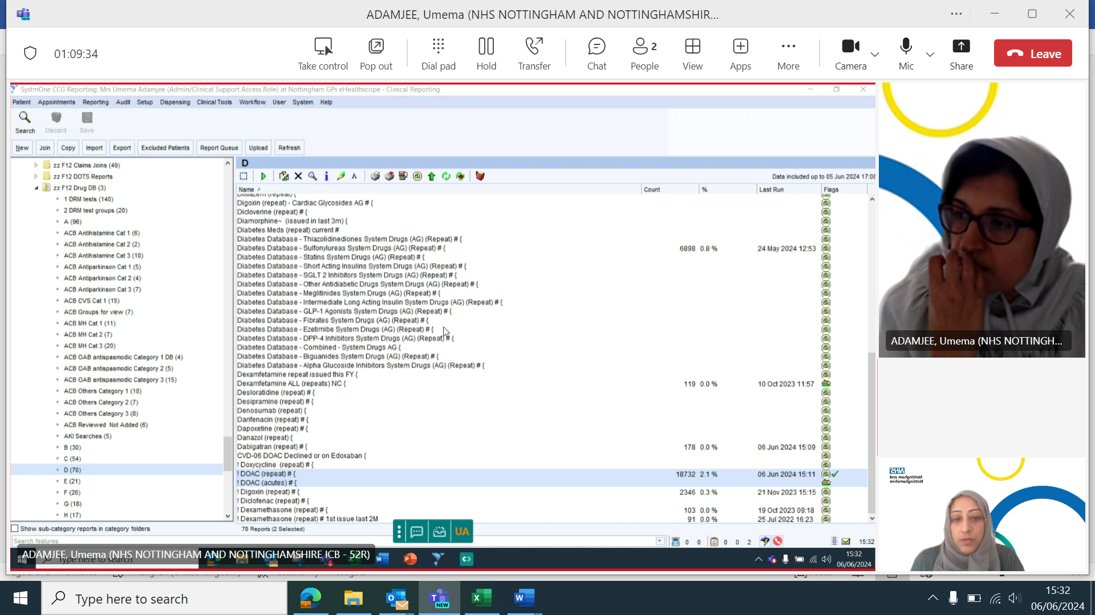

* Right click and then select **‘show patients’**.
* Click **‘Select output’** from the toolbar, then select **‘Pre-defined report output’** and then select **‘MSO AF DOAC MONITORING 2024’.**

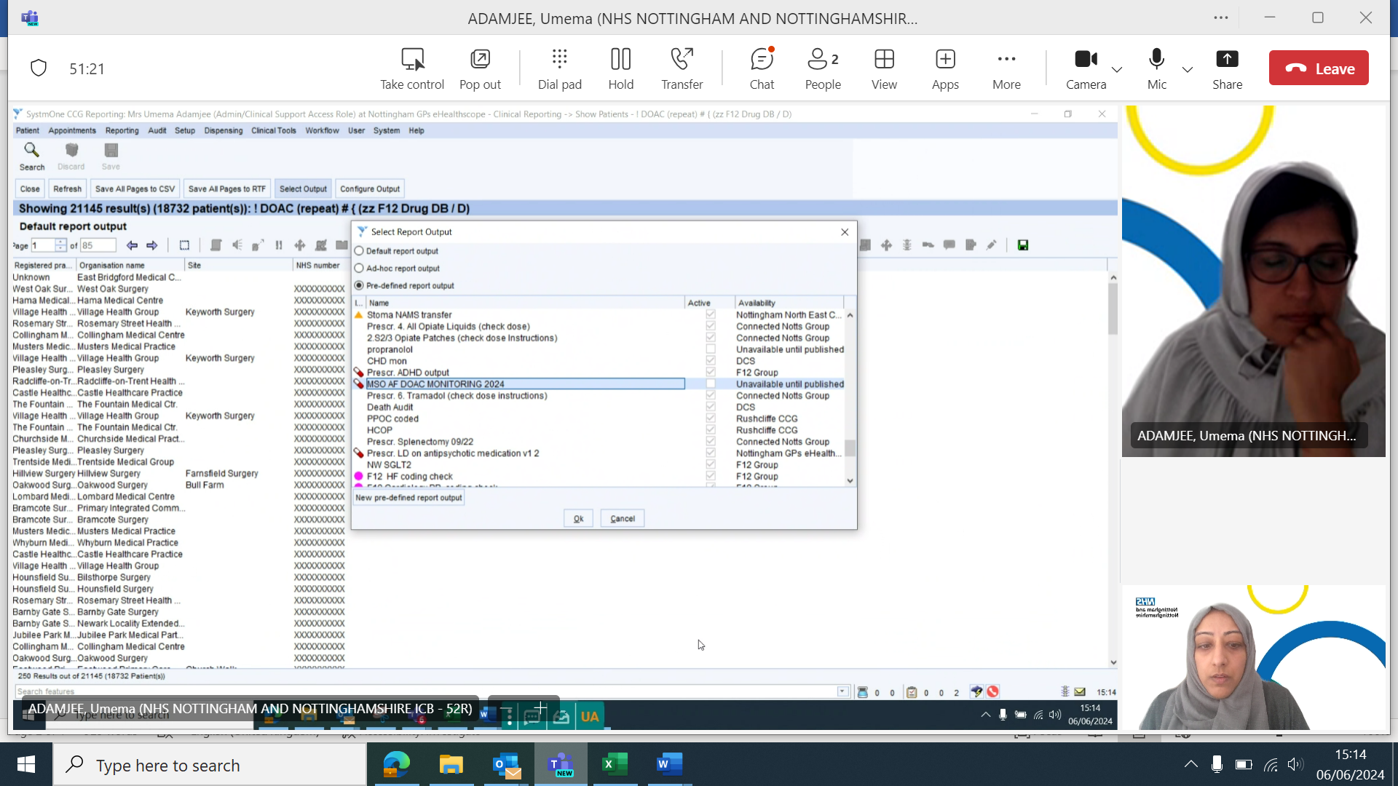

* Select all and then choose the **‘save as csv’** option from the toolbar to generate an excel spreadsheet.
* Save the excel spreadsheet onto the practice shared drive.
* Add in filters to all columns.
* Sort by drug name. Refer to [Nottinghamshire Area Prescribing Committee (Notts APC) Atrial Fibrillation (Non-valvular): prescriber decision support](https://www.nottsapc.nhs.uk/media/vlsfl14j/anticoagulants-in-af.pdf?UNLID=45973983820242295710) resource for appropriate dosing.
* Use Excel filters to identify gaps in monitoring of weights and creatinine clearance to then action accordingly. Please note where the search retrieves a blank indication the patient will need to be reviewed for indication and dose in line with the local guidance.
* Highlight patients identified for under or over dosing of DOAC in line with the [Nottinghamshire Area Prescribing Committee (Notts APC) Atrial Fibrillation (Non-valvular): prescriber decision support](https://www.nottsapc.nhs.uk/media/vlsfl14j/anticoagulants-in-af.pdf?UNLID=45973983820242295710) resource to clinician where appropriate.
* Repeat all steps from **‘zz F12 Drug DB’** select **‘▪ D’**. Run the search titled **‘! DOAC (acutes) # {‘** to review acute prescriptions for DOACs in the past 2 months.

**EMIS**

* Go to **‘MSO Searches’** in the clinical tree.

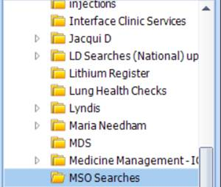

* Run the search **‘DOACs Feb2024 Auto Report’**.
* Click on the **‘View Results’** icon.

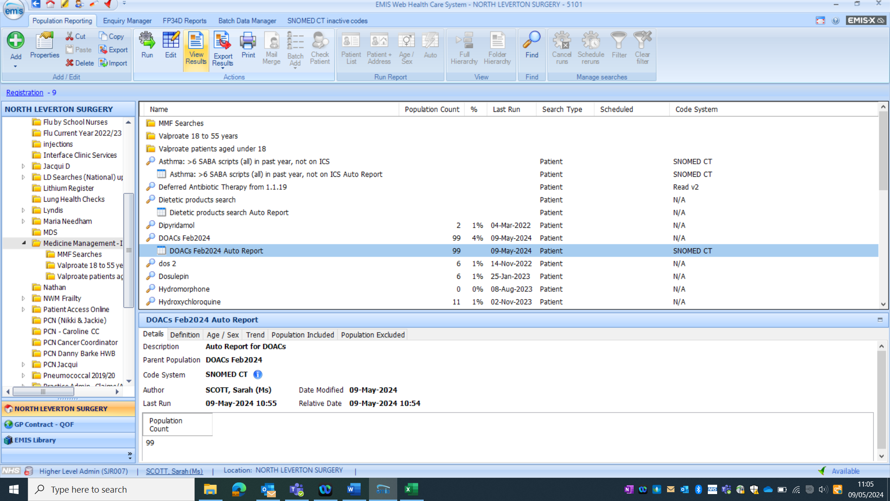

* Click on the **‘Export**’ icon.

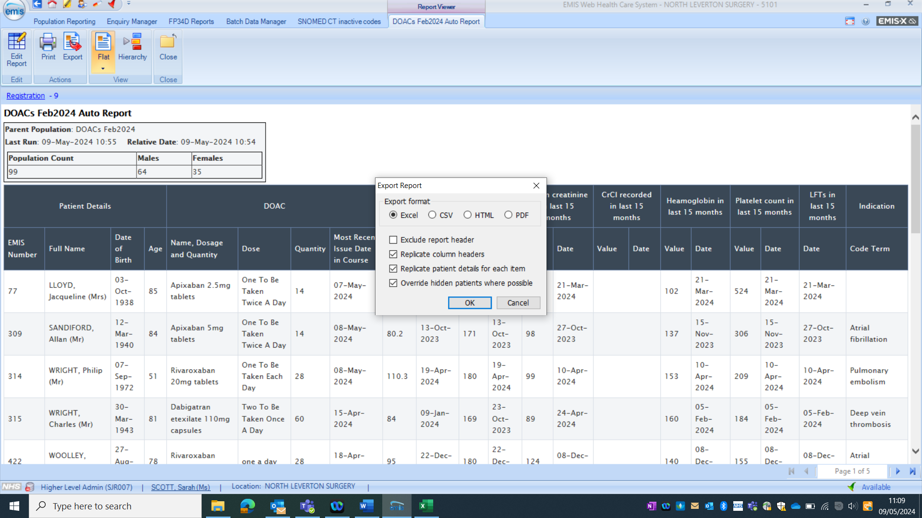

* Select the following options and then click **‘OK’**.



* Save the excel spreadsheet onto the practice shared drive.
* Add in filters to all columns.
* Sort by drug name. Refer to [Nottinghamshire Area Prescribing Committee (Notts APC) Atrial Fibrillation (Non-valvular): prescriber decision support](https://www.nottsapc.nhs.uk/media/vlsfl14j/anticoagulants-in-af.pdf?UNLID=45973983820242295710) resource for appropriate dosing.
* Use Excel filters to identify gaps in monitoring of weights and creatinine clearance to then action accordingly. Please note where the search retrieves a blank indication the patient will need to be reviewed for indication and dose in line with the local guidance.
* Highlight patients identified for under or over dosing of DOAC in line with the [Nottinghamshire Area Prescribing Committee (Notts APC) Atrial Fibrillation (Non-valvular): prescriber decision support](https://www.nottsapc.nhs.uk/media/vlsfl14j/anticoagulants-in-af.pdf?UNLID=45973983820242295710) resource to clinician where appropriate.

**eHealthScope**

1. Open eHealthScope in a web browser ([Home - eHealthScope (icb.nhs.uk)](https://ehs.notts.icb.nhs.uk/) (https://ehs.notts.icb.nhs.uk)
2. Click on **‘Registers’** in the menu bar.

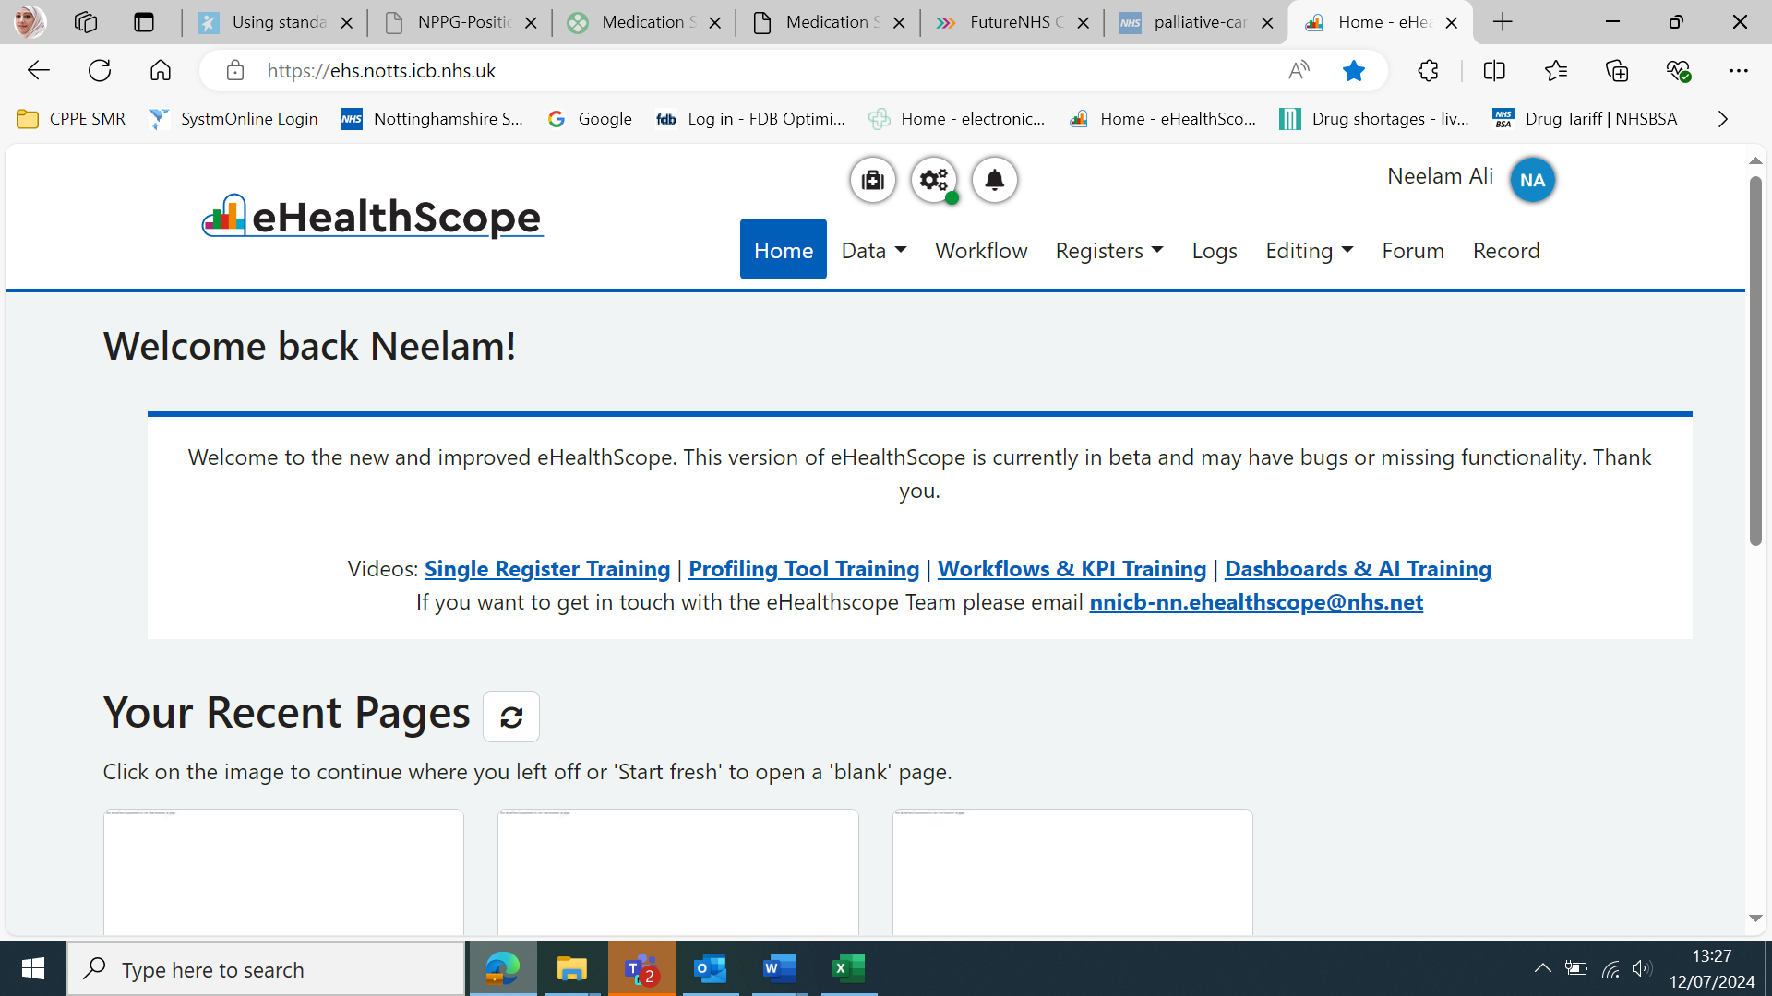

1. Select **‘Medicines Safety (MSO) Audits’** from the **‘Topic Category’**. Pick the topic you wish to look at e.g. AF pts >75yrs old on dabigatran and click **‘Filter single register’**.

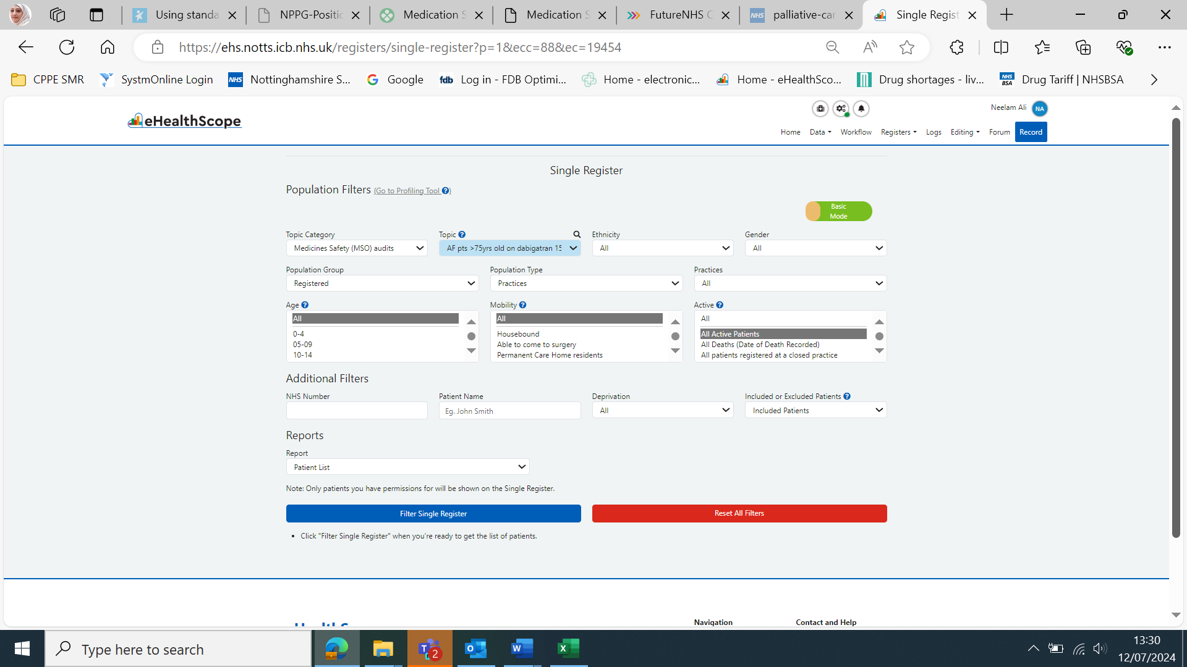

1. The list of patients will be displayed below.

If the list does not appear it probably means you do not have patient level permissions. Ask the practice manager to check the permissions log and click the link **‘add permissions for a user and allow them to see practice & patient data’** to enable your access.

**Further work areas for consideration:**

* **Directions**

Repeat templates should have clear, unambiguous directions outlining the number and frequency e.g., 1bd is not acceptable.

Rivaroxaban 15mg and 20mg tablets need to be taken **with food** so this should be stated in the directions.

* **Compliance**

Patients who are not requesting scripts regularly should be identified and reviewed by a clinician.

Ensure any DOACs that are no longer indicated are removed from the repeat template.

* For **Dabigatran** – consider reviewing DOAC choice in patients with increased risk of bleeding, gastritis, moderate renal impairment (CrCl 30-50ml/min) or aged 75-80 years.
* **Teratogenic workstream:** Female of childbearing potential e.g. <55 years of age and prescribed a DOAC with no code for hysterectomy.

***Disclaimer***

*This resource has been developed to facilitate the safe and effective review of DOACs, using current accessible references and is correct at the time of approval.*

*The output of the searches relies on accurate read coding. Clinicians using this resource must refer to local guidelines, use their own clinical judgement and take responsibility for their prescribing decisions.*

*Nottingham and Nottinghamshire ICB (N&N ICB) Medicines Optimisation Team only have oversight for the management of errors occurring within their own organisation. Each organisation is therefore responsible for any prescribing errors or omissions that may occur within their organisation because of using this resource and must follow their own safety governance process.*

*Organisations must inform N&N ICB Medicines Optimisation team should they become aware of any errors or updates required within the DOAC review documents.*

**Appendix 1.**

**Direct acting oral anticoagulants (DOACs) use in non-valvular atrial fibrillation (NVAF)**

**dosing and monitoring feedback sheet**

**Practice Name: Review date:**

|  |  |
| --- | --- |
| **Total number of adult patients prescribed a DOAC for the treatment of NVAF** |  |

|  |  |
| --- | --- |
| **Monitoring parameters** | |
| **Number of patients without a weight recorded in the last 12 months** |  |
| **Number of patients without a serum creatinine recorded in the last 12 months** |  |
| **Number of patients without creatinine clearance (CrCl) recorded within the last 12 months** |  |
| **Number of patients with CrCl < 15ml/min** |  |
| **Number of patients without haemoglobin or platelets recorded in last 12 months** |  |
| **Number of patients without liver function tests (LFTs) recorded in last 12 months** |  |

|  |  |
| --- | --- |
| **Prescribing parameters – Rivaroxaban** | |
| **Number of patients prescribed Rivaroxaban 20mg with a CrCl <50ml/min** |  |
| **Number of patients prescribed Rivaroxaban 15mg with a CrCl >50ml/min** |  |

|  |  |
| --- | --- |
| **Prescribing parameters - Edoxaban** | |
| **Number of patients prescribed Edoxaban 60mg with a body weight of ≤60kg** |  |
| **Number of patients prescribed Edoxaban 60mg with a CrCl <50ml/min** |  |
| **Number of patients prescribed Edoxaban 60mg with a CrCl >95ml/min** |  |
| **Number of patients prescribed Edoxaban 30mg with a CrCl >50ml/min and body weight > 60kg** |  |

|  |  |
| --- | --- |
| **Prescribing parameters- Apixaban** | |
| **Number of patients prescribed Apixaban 5mg who have at least 2 of the following criteria i.e. age ≥80yrs, body weight ≤60kg, serum creatinine ≥133µmol/L** |  |
| **Number of patients prescribed Apixaban 2.5mg who have at least 2 of the following criteria i.e. age <80yrs, body weight >60kg, serum creatinine <133 µmol/L** |  |

|  |  |
| --- | --- |
| **Prescribing parameters - Dabigatran** | |
| **Number of patients prescribed Dabigatran 150mg in age > 75 years** |  |
| **Number of patients prescribed Dabigatran 150mg with a CrCl 30-50ml/min** |  |

**References:**

1. Nottinghamshire APC Atrial Fibrillation (Non-valvular): prescriber decision support on anticoagulation

<https://www.nottsapc.nhs.uk/media/vlsfl14j/anticoagulants-in-af.pdf?UNLID=45973983820242295710>. (Accessed 02.02.24).

1. Nottinghamshire Area Prescribing Committee Formulary.

<https://www.nottinghamshireformulary.nhs.uk/chaptersSubDetails.asp?FormularySectionID=2&SubSectionRef=02.08.02&SubSectionID=A100&drugmatch=3620#3620>. (Accessed 02.02.24).

1. Medicines Safety Improvement programme: Anticoagulant safety improvement programme. FutureNHS Platform <https://future.nhs.uk/MedicinesSafetyImprovement/view?objectID=30423344> (Accessed 02.02.24). (Login required)
2. NICE Clinical Knowledge Summaries:Atrial fibrillation.

<https://cks.nice.org.uk/topics/atrial-fibrillation/#!topicSummary>

Last revised in March 2023. (Accessed 12.07.24).

1. Safety of direct-acting oral anticoagulant (DOAC) prescribing. Open SAFLEY-TPP analysis of 20.5 million adults’ electronic health records. Homan K, Seeley R et al December 2023. British Journal of General Practice

OPEN DOI: <https://doi.org/10.3399/BJGPO.2023.0163> (Accessed 21.03.24)

|  |  |  |  |
| --- | --- | --- | --- |
| Version Control - Direct acting oral anticoagulants (DOACs) use in non-valvular atrial fibrillation (NVAF). Dosing and monitoring audit information sheet. | | | |
| Version | Author(s) | Date | Changes |
| 1.0 | Umema Adamjee and Neelam Ali | 10.07.2024 | Addition of ® to brand names, CKS link updated, teratogenic work is added to the further work areas and E-Healthscope screen shots updated to the new version. |
| 1.1 | Umema Adamjee and Neelam Ali | 27.08.2024 | Ehealthscope link updated to the new one. |
| 1.2 | Umema Adamjee and Neelam Ali | 08.10.2024 | Changed heading to ‘healthcare professionals’. Added edoxaban information for interacting medicines. Added note where the search retrieves a blank indication the patient will need to be reviewed for indication and dose in line with the local guidance. Updated disclaimer. |
| 1.3 | Umema Adamjee and Neelam Ali | 07.11.2024 | For Healthcare professionals working in Doncaster and Bassetlaw (D&B) the traffic light status and formulary for this area applies. However, prescribers can use Nottingham and Nottinghamshire guidance if equivalent D&B guidance is not available |