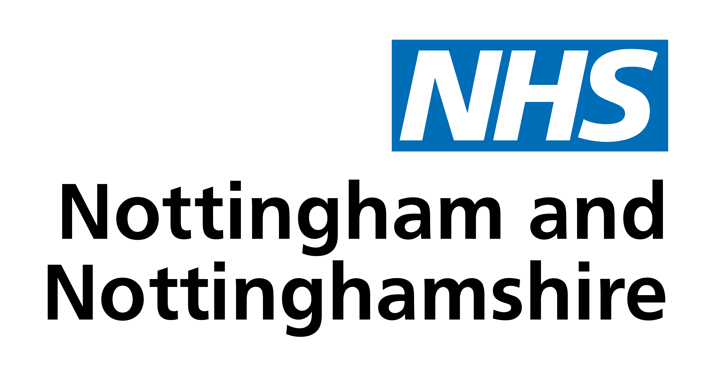

Non NHS Organisations Visit Request Form

This form is for representatives wishing to see a member of the Medicines Optimisation Team at NHS Nottingham and Nottinghamshire. The Medicines Optimisation Team will proactively contact pharmaceutical representatives if they wish to meet with them. If your request is for a meeting and we do not reply within 2 weeks, please take that to imply that your request has been declined.

Drug Company | Date
Contact details (Name/email/mobile number)

Reason for request (please tick all that apply)
New Drug |  | New information on patient safety or C/I
Published comparative data |  | Published Patient outcome data
Changes to cost |  | Other (please list):

The following information will be required in order to evaluate your request:

- Name of drug/product

- Licensed indication

- Place in therapy

- Advantages/disadvantages over current therapies (if applicable)

- Published literature

- National guidance

- Economic evaluation (Nationally, locally)

- Area of prescribing (primary/secondary care)

- Companies current marketing strategy

- Any other relevant information.

Please note that if insufficient information is received the submission will not be
considered

Forms should be returned to:

nnicb-nn.medsman@nhs.net

NHS Nottingham and Nottinghamshire
notts.icb.nhs.uk/

