Gabapentin and Pregabalin prescribing for neuropathic pain.
Prescribing in patients aged 65 years or over.

This information is aimed for use by healthcare professionals in a GP practice.

Key Message:

This resource has been developed to enable Healthcare Professionals to:

- Review the safety of prescribing of gabapentinoids for neuropathic pain in patients aged 65 or over.
- Ensure that the risk of side effects is reviewed for patients in this cohort co-prescribed a strong opioid.
- Ensure that dosing of gabapentinoids in this patient cohort is as safe as possible in relation to renal function.
- Reduce the risk of patients experiencing avoidable harm from gabapentinoids when used for neuropathic pain.

For full prescribing guideline see: Management of Neuropathic Pain for Adults in Primary Care

Background:

- People experiencing persisting non-cancer pain have complex care needs that can be challenging to meet in primary care settings^{1,2,3}.
- Effective pain management for most people will require a collaborative approach where the person is informed, listened to, and actively involved to the extent that they wish in decision making^{1,2,3}.
- Treatment with a gabapentinoid is associated with dizziness and sedation, which could increase the occurrence of accidental injury (fall) in the elderly population^{4,5}.
- Gabapentin⁶ and pregabalin⁷ are associated with rare/infrequent risk of respiratory depression. The MHRA advises prescribers to show caution when initiating gabapentin or pregabalin and consider whether adjustments in dose or dosing regimen are necessary in patients at higher risk of respiratory depression, including those:
  - with compromised respiratory function, respiratory or neurological disease, or renal impairment.
  - taking other CNS depressants (including opioid-containing medicines).
  - aged older than 65 years.
  - special precaution should be taken for patients’ co-prescribed opioid and Pregabalin at doses exceeding 300mg a day.
- Patients co-prescribed an opioid with gabapentin and / or pregabalin are at an increased risk of side effects such as sedation and respiratory depression^{4,5,6,7.}
- Renal impairment will decrease gabapentinoids elimination and result in potential drug accumulation⁸.
- It is good practice to review patients with declining kidney function known to be using gabapentinoids⁸.
- Estimated glomerular filtration rate (eGFR) can overestimate renal function and increase the risk of side-effects and therefore creatinine clearance (CrCl) is recommended for use⁸. See Management of Neuropathic Pain for Adults in Primary Care for information about dosing.

Actions:

- Use the search on SystmOne, EMIS, eHealthscope to identify patients prescribed gabapentinoids aged 65 years or over.
- Ensure the following higher risk groups have a recorded renal function in the last 15 months:
  - Patients prescribed gabapentinoids aged >65 years.
  - Patients prescribed gabapentinoids aged >65 and co-prescribed a strong opioid (see BNF for information on strong opioids Analgesics | Treatment summaries | BNF | NICE).
- Ensure that patients with impaired or declining renal function (eGFR<90ml/min) have a CrCl recorded (weight and serum creatinine also taken within the last 15 months):
- Review the dose to ensure it meets the requirements of the dosing schedule in the Nottinghamshire APC guidance.
- Ensure patients aged 65 years or over prescribed gabapentinoids and co-prescribed a strong opioid have had a structured medication review in the last 12 months highlighting risks of side effects such as sedation and respiratory depression.

Data:

Patient identifiable data is available through eHealthscope, SystmOne and EMIS.

SystmOne
- Select ‘Reporting’ from the toolbar, then ‘Clinical Reporting’ which should open the clinical tree. Open the subsection titled ‘F12 Group’.
- Using ‘F12 007 ICB Meds Op searches’ select ‘001b MSO workstreams’ and then ‘gabapentinoids (repeat) # {‘as highlighted below.

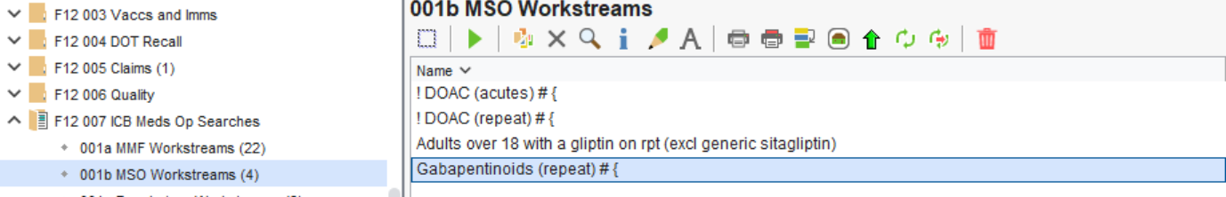

- Run report and then select show patients.
- Click ‘Select output’ from the toolbar, then select ‘pre-defined report output’ and then select ‘MSO Gabapentin / pregabalin 2024/25’.
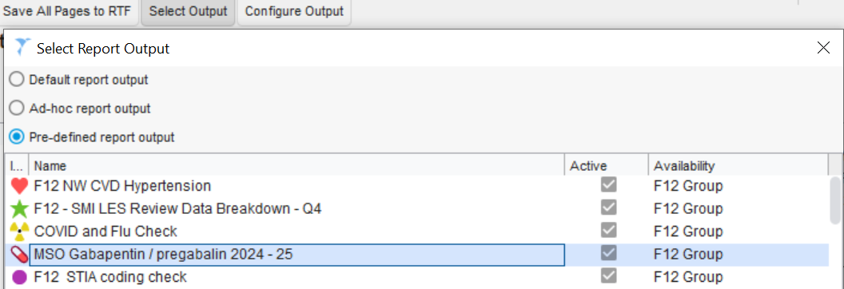

- Select the ‘save all pages to csv’ option from the toolbar to generate an excel spreadsheet.
- Save the excel spreadsheet onto the practice shared drive.
- Add in filters to all columns.
- Sort by drug name and refer to Nottinghamshire APC Guidance for Neuropathic Pain guidance for appropriate dosing.
- Use Excel filters to identify renal function recording, and declining renal function, monitoring of weights and serum creatinine and then action accordingly.
- Identify patients who require a CrCl or are on a dose outside of APC guidance.

EMIS
- Go to ‘MSO Searches’ in the clinical tree.
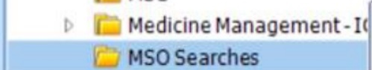
- Run the search ‘Gabapentinoids 2024 / 25 Auto Report’.
- Click on the ‘View Results’ icon.
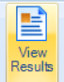
- Click on the ‘Export’ icon.
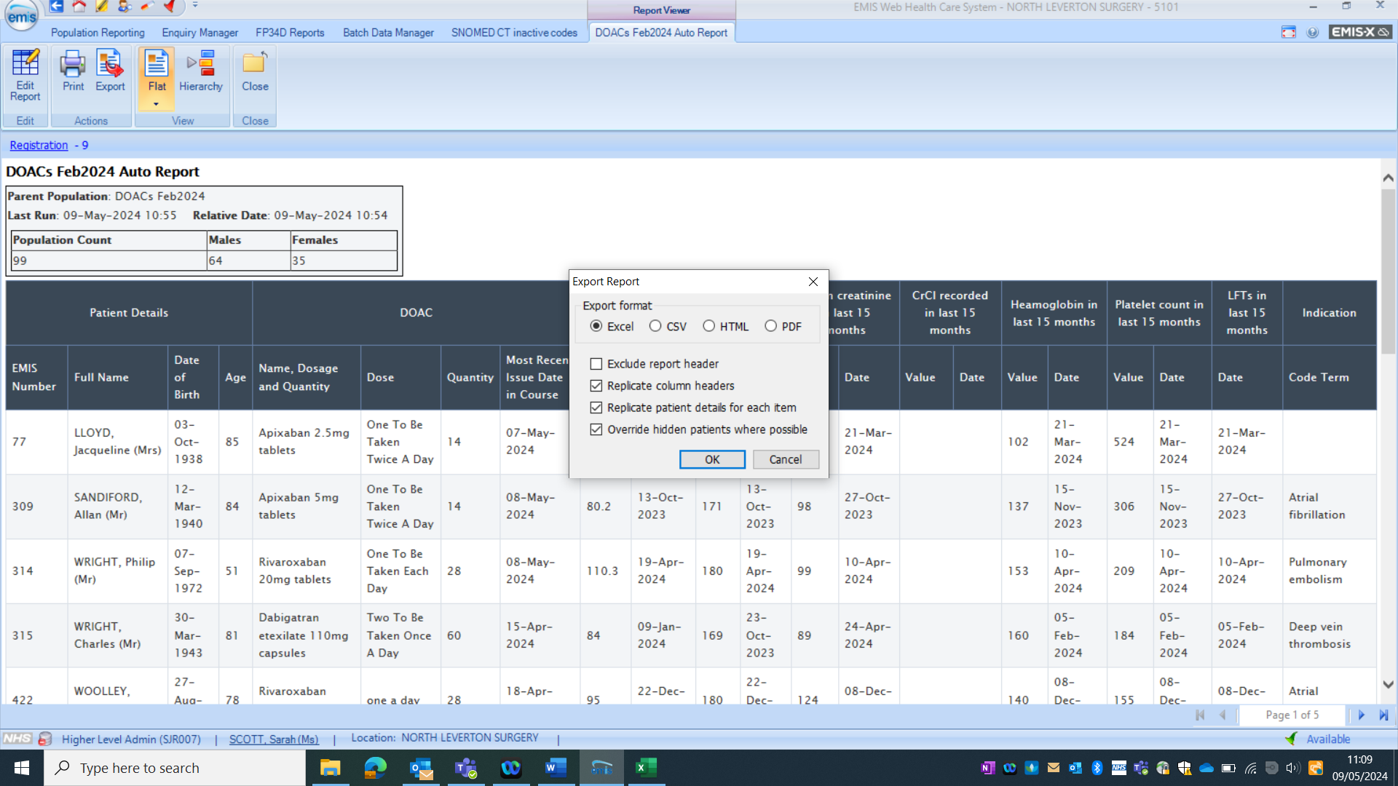
- Select the following options and then click ‘OK’.
- Save the excel spreadsheet onto the practice shared drive.
- Add in filters to all columns.
- Sort by drug name. Refer to Nottinghamshire APC Guidance for Neuropathic Pain resource for appropriate dosing.
- Use Excel filters to identify recording of renal function and declining renal function, monitoring of weights and creatinine clearance to then action accordingly.
- Use Excel filters to identify patients requiring dose review in relation to creatinine clearance and action accordingly.

eHealthScope
- Open eHealthscope in a web browser (https://ehs.notts.icb.nhs.uk)
- Click on KPIs.
- Then open “Prescribing” from the “Topic Categories”, pick the topic you wish to look at as shown below.
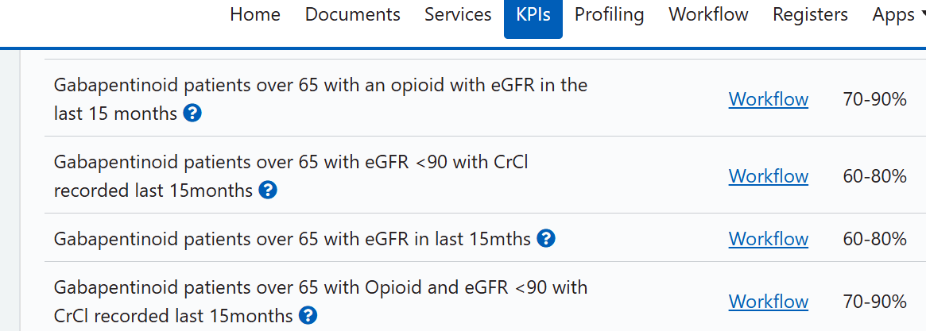
- Select “workflow” to access patient list.
If the list does not appear it probably means you do not have patient-level permissions. Ask the practice manager to check the permissions log and click the link “add permissions for a user and allow them to see practice & patient data” to enable your access.

Disclaimer

- This resource has been developed to facilitate the safe and effective review of gabapentin and pregabalin. The output of the searches relies on accurate read coding. Clinicians using this resource must refer to local guidelines, use their own clinical judgement and take responsibility for their prescribing decisions.
- Nottingham and Nottinghamshire ICB (N&N ICB) Medicines Optimisation team only take responsibility of errors occurring within their own organisation. Each organisation is therefore responsible for any prescribing errors or omissions that may occur within their organisation because of using this resource and must follow their own safety governance process.
- Organisations must inform N&N ICB Medicines Optimisation team should they become aware of any errors or updates required within the Gabapentinoids review documents.

References:

- Recommendations | Chronic pain (primary and secondary) in over 16s: assessment of all chronic pain and management of chronic primary pain | Guidance | NICE. Accessed 10/06/25.
- Nottinghamshire Area Prescribing Committee Management of Chronic Pain in Patients above 16 years of age. Accessed 10/06/25.
- Medicines associated with dependence or withdrawal symptoms: safe prescribing and withdrawal management for adults (nice.org.uk). Accessed 10/06/25.
- Pregabalin 100 mg hard capsules - Summary of Product Characteristics (SmPC) - (emc) (medicines.org.uk). Accessed 10/06/25.
- Gabapentin 100 mg capsules - Summary of Product Characteristics (SmPC) - (emc) (medicines.org.uk). Accessed 10/06/25.
- Gabapentin (Neurontin): risk of severe respiratory depression - GOV.UK (www.gov.uk). Accessed 10/06/25.
- Pregabalin (Lyrica): reports of severe respiratory depression - GOV.UK (www.gov.uk). Accessed 10/06/25.
- NHS Nottinghamshire Area Prescribing Committee guidance for Neuropathic Pain. Accessed 10/06/26.

Version control
Version Control - Gabapentin and Pregabalin prescribing for neuropathic pain. Prescribing in patients aged 65 years or over
Version | Author(s) | Date | Changes
1.0 | Nirlas Bathia, Claire McCooey | 23/07/24
2.0 | Nirlas Bathia | 10/06/25 | Added information about structured medication reviews for patients co-prescribed a strong opioid. Updated S1 search information. Updated links. Added accessibility disclaimer.
3.0 | Nirlas Bathia | 29/01/26 | Updated pathway to S1 search and eHealthscope data.

