**Using the SystmOne formulary**

The SystmOne formulary can help you to identify preferred products to prescribe. It incorporates the [Preferred Prescribing List](https://www.nottinghamshiremedicinesmanagement.nhs.uk/media/1383/preferred-brands_aide-memoire.pdf), designed to promote cost-effective prescribing through guided choice of brand, formulation and strength of medication. This is regularly updated by the ICB Medicines Optimisation Team.

**Setting up your user preferences**When prescribing a new drug, you will see the prescribing window below. Please ensure the “formulary entries” box is ticked and the “£” symbol is selected as indicated below. You will only need to do this once then this will be your default setting allowing you to make the most of the formulary.

**Tick the   
“Formulary entries” box**

**Click on the £ symbol to display drug costs**

Preferred items appear at the top* with the following symbol:  
 

*except Mid Notts practices

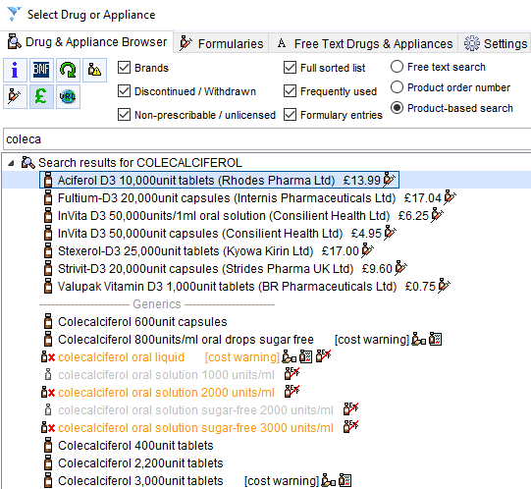

Be cautious of products which show no price or “cost warning”. This often denotes a “special order” product which can be expensive.

**Other settings**

* If the drug appears in **ORANGE text** – the item is non-prescribable / unlicensed or not to be prescribed generically.
* If the drug appears in **GREY** text - the item is discontinued / withdrawn.
* If the text is **RED** - it means the item is high risk (often a red traffic light drug).
* Note orange and grey text will only appear if you have ticked the “Discontinued / Withdrawn” or “Non-prescribable / unlicensed” boxes.
* If the “Frequently used” box is ticked, a green asterisk * appears next to items that you prescribe most often. Please note that this can be misleading if you have regularly prescribed non-formulary items.